Copyright reserved

Please turn over

**NATIONAL CERTIFICATE**

**MECHANOTECHNICS N4**

**April 2020**

**2**

**This marking guideline consists of 8 pages.**



**MARKING GUIDELINE**

-2-

# QUESTION 1

1.1 • Finding a suitable locality.

* Dividing the locality into various work areas.
* Placing all equipment and services in the relevant areas.
* Comparing possible layout designs before adopting the most effective

one. (4)

1.2 • Production is not continuous.

* There is extensive handling of workpieces being transported to other sections.
* Costs are higher due to specialised inspection methods.
* More floor space is required for storage of in-process material.
* Control is difficult.
* Careful, detailed scheduling of working activities is required. (6)

1.3 • Gravity feed

* Grease lubrication
* Splash lubrication
* Forced lubrication
* Pressure-feed lubrication (5)

1.4 • They have lower torque resistance.

* They require less resistance.
* They can support both radial and axial loads.
* They require little axial space.
* They are easy to replace.
* They require very little maintenance.
* They can take heavy overloads.
* They give warning, by becoming noisy, when they begin to fail.
* They can maintain high rotational speeds.
* The bearings can be pre-packed and sealed with a lubricant. (Any 5 × 1) (5)

1.5 • There is an excessive use of paint.

* Large quantities of paint are kept in paint dip troughs.
* There is a considerable loss of thinners through evaporation.
* Dip-painting is only for mass production.
* If paint is left overnight in dip troughs, continual, thorough agitation is

needed the following day. (5)

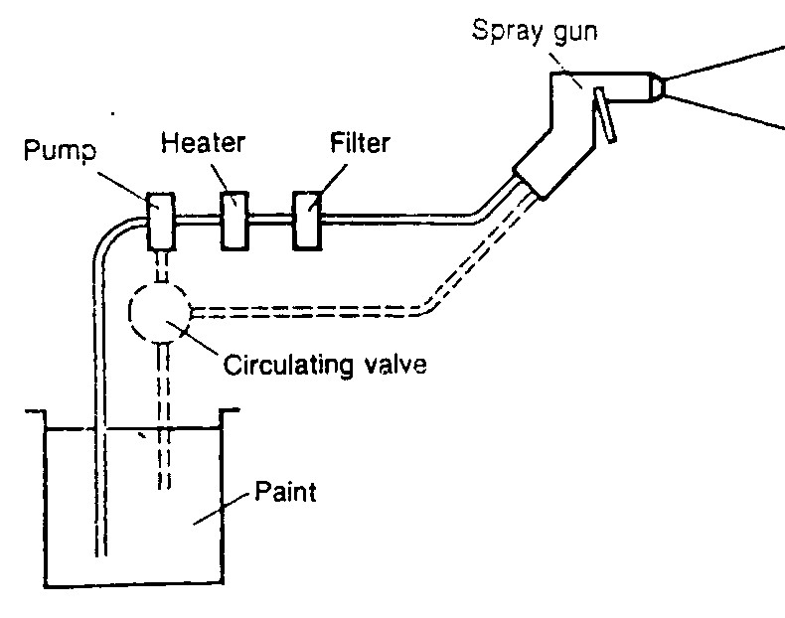1.6

(Any 3 labels, but 'Heater' must be one of them) (3 × 1) (3)

(Drawing) (2)

**[30]**

# QUESTION 2

2.1 π(*D*+*t*)×*n*  *v* =

60

=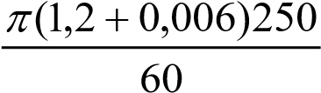✓

=15,787*m s*/ ✓

*T*1 =σ× ×*w t*

*T*1 = 900 10× × ×3 0,3 0,006✓

*T*1 =1620*N* ✓

*T*

1 = 3,5 *T*2

*T*

*T*2 = 1

=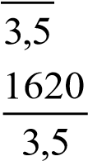✓

*T*2 = 462,857*N* 

*P* = −(*T*1 *T v*2)

= (1620 − 462,857)15,787 

*P* =18267,814*W*

*P* =18,268*kW*  (8)

2.2 π (*D d*− )2

*L* = (*D d*+ +) + 2*C*

2 4*C*

(1,2−0,4)2

= (1,2+0,4)+ + 2 1× ,5

4 1× ,5

= 2,513+ 0,107 + 3

= 5,62*m* (3)

2.3 π (*D d*+ )2

*L* = (*D d*+ +) + 2*C*

2 4*C*

(1,2+0,4)2

= (1,2+0,4)+ + 2 1× ,5

4 1× ,5

= 2,513+ 0,427 + 3

= 5,94*m* (3)

**[14]**

# QUESTION 3

3.1 *horozontal force F*1  µ=

*NR*

*NR* = *magnetic force F*2 + *mg*

900

0,25 = 

*F*2 + (12×9,81)

0,25*F*2 + 29,43 = 900

*F*2 =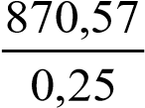

|  |  |  |  |  |  |
| --- | --- | --- | --- | --- | --- |
|  | = 3482,28*N*  |  |  |  | (6) |
| 3.2 | *Ff*  µ=  *load on bearing F*  *Ff* =µ×*F*  *Ff* = 0,03 90 10× × 3  *Ff* = 2700*N*     *Tf* = *Ff* ×*r* | ***OR*** | *Ff*  µ=  *load on bearing F*  *Ff* =µ×*F*  *Ff* = 0,03 90 10× × 3  *Ff* = 2700*N*     π*DN*  *v* = |  |  |

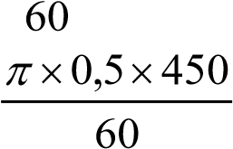 *Tf* = 2700×0,25

= 675*N m*. =

2π*NTf* =11,781*m s*/ 

*Pf* =

60

2× ×π 450×675  *Pf* = *Ff* ×*v*

*Pf* = = 2700 11,781× 

60

= 31808,626*W* = 31808,626*W*  (8)

# [14] QUESTION 4

4.1

°

58

Ø20

°

62

**A**

**B**

X

**E F**

125

**C**

**D**

*X* =125− −2*r AB EF*−

*r* =12,5

10

*In* ∆*ABC* tan61°=

*AB*

10

*AB* = tan61°

*AB* = 5,543*mm*

10

*In* ∆*DEF* tan59°=

*EF*

10

*EF* = tan59°

*EF* = 6,009*mm*

*X* =125 2− −*r AB EF*− 

*X* =125− 2(10) −5,543−6,009

*X* = 93,448*mm* (7)

4.2

Ø

mm

20

**A**

**B**

**D**

Ø12 mm

°

30

**C**

X

**Distance BC**

E

**F**

(Sketch = 1 mark for the right-angled triangle ∆*EDC* ) (1)

*X* = *BC*−*CE*−*EF*

*Find BC*

*In* ∆*ABC*

*AB*

tan15°=  *BC*

10

*BC* = 

tan15°

= 37,321*mm*

*Find CE*

*In* ∆*CDE*

*DE*

sin15°=

*CE*

6

*CE* = 

sin15°

= 23,182*mm*

*X* = *BC*−*CE*−*EF*

*X* = 37,321− 23,182 − 6

= 8,139 mm (6)

# [14] QUESTION 5

5.1 *PCD*  *m*=

*TB*

*PCD*

8 =

40

*PCD* =320*mm*

*VR* = 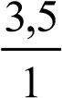

*TA* 3,5

=

*TB* 1

*TA* 3,5

= 

40 1

*TA* =140

*PCD*

*m*=

*TA*

*PCD*

8 =

140

*PCD* =1120*mm* (4)

5.2 *m*

*C* = (*TA* +*TB* )

2

= (140 + 40)

= 4 180× 

= 720*mm* (3)

5.3 *DOA* =*mT*( *A* + 2)

= 8(140 + 2)

= 8 142×

=1136*mm*

*DOB* =*mT*( *B* + 2)

= 8(40 + 2) 

= 8×42

= 336*mm* (4)

5.4 *addendum = m* 

*addendum = 8*

*dedendum = 1,157* x *m*

*= 1,157* x *8*

= *9,256 mm* 

*total depth = addendum + dedendum*

= +8 9,256

*=* *17,256 mm*  (3)

**[14]**

-8-

# QUESTION 6

*Q*1 = *v*1*xA*1

*Q*1

*v*1 = *A*1

0,09

*v*1 = 2 

π/ 4(0,1)

*v* =11,46*m s*/ 

1

*Q*2 = *v*2*xA*2

*Q*

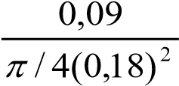 *v*2 = 2 *A*2

*v*2 =

*v* = 3,54*m s*/ 

2

*P*1 *v*12 *P*2 *v*22

+ + =*h*1 + +*h*2ρ*g* 2*g* ρ*g* 2*g*

230000 (11,46)2 *P*2 (3,54)2

3 + + =0 3 + +15

10 *x*9,81 2 9*x* ,81 10 *x*9,81 2 9*x* ,81

*P*2

23,445+ 6,693 = + 0,64 +15

9810 *P*

2 = 30,138−15,64 

9810 *P*

2 =14,501

9810

*P*2 =142251,008*Pa*

*P*2 =142,251*kPa*  **[14]**

**TOTAL:**  **100**